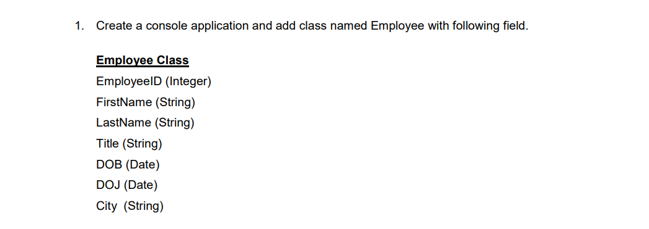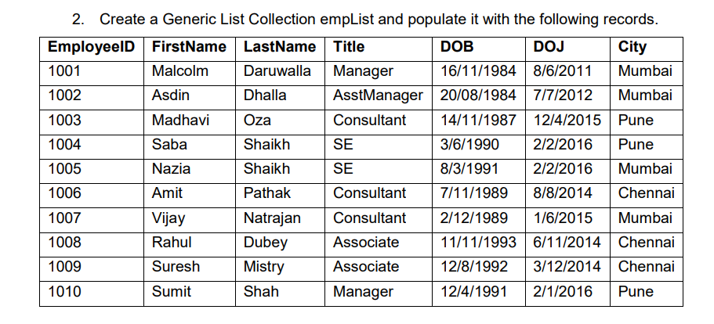

Display details all of employee.

using System;

using System.Linq;

using System.Collections.Generic;

class Employee {

public int EmployeeID{get;set;}

public string FirstName{get;set;}

public string LastName{get;set;}

public string Title{get;set;}

public DateOnly DOB{get;set;}

public DateOnly DOJ{get;set;}

public string City{get;set;}

}

class Emp{

static void Main() {

List<Employee> ListEmployee=new List<Employee>();

ListEmployee.Add(new Employee(){EmployeeID=1001,FirstName="Malcolm",LastName="Daruwalla",Title="Manager",DOB= new DateOnly(1984,11,16),DOJ=new DateOnly(2011,6,8),City="Mumbai"});

ListEmployee.Add(new Employee(){EmployeeID=1002,FirstName="Asdin",LastName="Dhalla",Title="AsstManager",DOB=new DateOnly(1984,08,20),DOJ=new DateOnly(2012,07,7),City="Mumbai"});

ListEmployee.Add(new Employee(){EmployeeID=1003,FirstName="Madhavi",LastName="Oza",Title="Consultant",DOB=new DateOnly(1987,11,14),DOJ=new DateOnly( 2015,4,12),City="Pune"});

ListEmployee.Add(new Employee(){EmployeeID=1004,FirstName="Saba",LastName="Shaikh",Title="SE",DOB=new DateOnly(1990,6,3),DOJ=new DateOnly(2016,2,2),City="Pune"});

ListEmployee.Add(new Employee(){EmployeeID=1005,FirstName="Nazia",LastName="Shaikh",Title="SE",DOB=new DateOnly(1991,3,8),DOJ=new DateOnly(2016,6,2),City="Mumbai"});

ListEmployee.Add(new Employee(){EmployeeID=1006,FirstName="Amit",LastName="Pathak",Title="Consultant",DOB=new DateOnly(1989,11,7), DOJ=new DateOnly(2014,8,8),City="Chennai"});

ListEmployee.Add(new Employee(){EmployeeID=1007,FirstName="Vijay",LastName="Natrajan",Title="Consultant",DOB=new DateOnly(1989,12,2),DOJ=new DateOnly(2015,6,1),City="Mumbai"});

ListEmployee.Add(new Employee(){EmployeeID=1008,FirstName="Rahul",LastName="Dubay",Title="Associoate",DOB=new DateOnly(1993,11,11),DOJ=new DateOnly(2014,11,6),City="Chennai"});

ListEmployee.Add(new Employee(){EmployeeID=1009,FirstName="Sureah",LastName="Mistry",Title="Associoate",DOB=new DateOnly(1992,8,12),DOJ=new DateOnly(2014,12,3),City="Chennai"});

ListEmployee.Add(new Employee(){EmployeeID=1010,FirstName="Sumit",LastName="Shah",Title="Manager",DOB=new DateOnly(1991,4,12),DOJ=new DateOnly(2016,1,2),City="Pune"});

var disp= from c in ListEmployee select c;

foreach(var EM in disp)

{

Console.WriteLine("{0} {1} {2} {3} {4} {5} {6}\n",EM.EmployeeID,EM.FirstName,EM.LastName,EM.Title,EM.DOB,EM.DOJ,EM.City);

}

}

}

Output:

}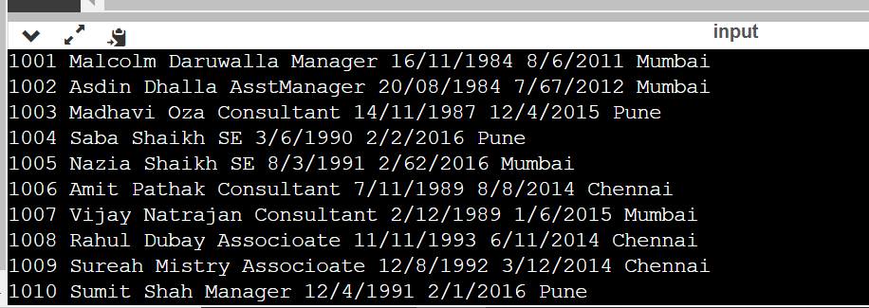

b. Display details all of employee whose location is not Mumbai.

using System;

using System.Linq;

using System.Collections.Generic;

class Employee {

public int EmployeeID{get;set;}

public string FirstName{get;set;}

public string LastName{get;set;}

public string Title{get;set;}

public DateOnly DOB{get;set;}

public DateOnly DOJ{get;set;}

public string City{get;set;}

}

class Emp{

static void Main() {

List<Employee> ListEmployee=new List<Employee>();

ListEmployee.Add(new Employee(){EmployeeID=1001,FirstName="Malcolm",LastName="Daruwalla",Title="Manager",DOB= new DateOnly(1984,11,16),DOJ=new DateOnly(2011,6,8),City="Mumbai"});

ListEmployee.Add(new Employee(){EmployeeID=1002,FirstName="Asdin",LastName="Dhalla",Title="AsstManager",DOB=new DateOnly(1984,08,20),DOJ=new DateOnly(2012,07,7),City="Mumbai"});

ListEmployee.Add(new Employee(){EmployeeID=1003,FirstName="Madhavi",LastName="Oza",Title="Consultant",DOB=new DateOnly(1987,11,14),DOJ=new DateOnly( 2015,4,12),City="Pune"});

ListEmployee.Add(new Employee(){EmployeeID=1004,FirstName="Saba",LastName="Shaikh",Title="SE",DOB=new DateOnly(1990,6,3),DOJ=new DateOnly(2016,2,2),City="Pune"});

ListEmployee.Add(new Employee(){EmployeeID=1005,FirstName="Nazia",LastName="Shaikh",Title="SE",DOB=new DateOnly(1991,3,8),DOJ=new DateOnly(2016,6,2),City="Mumbai"});

ListEmployee.Add(new Employee(){EmployeeID=1006,FirstName="Amit",LastName="Pathak",Title="Consultant",DOB=new DateOnly(1989,11,7), DOJ=new DateOnly(2014,8,8),City="Chennai"});

ListEmployee.Add(new Employee(){EmployeeID=1007,FirstName="Vijay",LastName="Natrajan",Title="Consultant",DOB=new DateOnly(1989,12,2),DOJ=new DateOnly(2015,6,1),City="Mumbai"});

ListEmployee.Add(new Employee(){EmployeeID=1008,FirstName="Rahul",LastName="Dubay",Title="Associoate",DOB=new DateOnly(1993,11,11),DOJ=new DateOnly(2014,11,6),City="Chennai"});

ListEmployee.Add(new Employee(){EmployeeID=1009,FirstName="Sureah",LastName="Mistry",Title="Associoate",DOB=new DateOnly(1992,8,12),DOJ=new DateOnly(2014,12,3),City="Chennai"});

ListEmployee.Add(new Employee(){EmployeeID=1010,FirstName="Sumit",LastName="Shah",Title="Manager",DOB=new DateOnly(1991,4,12),DOJ=new DateOnly(2016,1,2),City="Pune"});

var dis= from i in ListEmployee where i.City!="Mumbai" select i;

foreach(var EM in disp)

{

Console.WriteLine("{0} {1} {2} {3} {4} {5} {6}\n",EM.EmployeeID,EM.FirstName,EM.LastName,EM.Title,EM.DOB,EM.DOJ,EM.City);

}

}

}

Output:



C. Display details of all the employee whose title is asstmanager.

using System;

using System.Linq;

using System.Collections.Generic;

class Employee {

public int EmployeeID{get;set;}

public string FirstName{get;set;}

public string LastName{get;set;}

public string Title{get;set;}

public DateOnly DOB{get;set;}

public DateOnly DOJ{get;set;}

public string City{get;set;}

}

class Emp{

static void Main() {

List<Employee> ListEmployee=new List<Employee>();

ListEmployee.Add(new Employee(){EmployeeID=1001,FirstName="Malcolm",LastName="Daruwalla",Title="Manager",DOB= new DateOnly(1984,11,16),DOJ=new DateOnly(2011,6,8),City="Mumbai"});

ListEmployee.Add(new Employee(){EmployeeID=1002,FirstName="Asdin",LastName="Dhalla",Title="AsstManager",DOB=new DateOnly(1984,08,20),DOJ=new DateOnly(2012,07,7),City="Mumbai"});

ListEmployee.Add(new Employee(){EmployeeID=1003,FirstName="Madhavi",LastName="Oza",Title="Consultant",DOB=new DateOnly(1987,11,14),DOJ=new DateOnly( 2015,4,12),City="Pune"});

ListEmployee.Add(new Employee(){EmployeeID=1004,FirstName="Saba",LastName="Shaikh",Title="SE",DOB=new DateOnly(1990,6,3),DOJ=new DateOnly(2016,2,2),City="Pune"});

ListEmployee.Add(new Employee(){EmployeeID=1005,FirstName="Nazia",LastName="Shaikh",Title="SE",DOB=new DateOnly(1991,3,8),DOJ=new DateOnly(2016,6,2),City="Mumbai"});

ListEmployee.Add(new Employee(){EmployeeID=1006,FirstName="Amit",LastName="Pathak",Title="Consultant",DOB=new DateOnly(1989,11,7), DOJ=new DateOnly(2014,8,8),City="Chennai"});

ListEmployee.Add(new Employee(){EmployeeID=1007,FirstName="Vijay",LastName="Natrajan",Title="Consultant",DOB=new DateOnly(1989,12,2),DOJ=new DateOnly(2015,6,1),City="Mumbai"});

ListEmployee.Add(new Employee(){EmployeeID=1008,FirstName="Rahul",LastName="Dubay",Title="Associoate",DOB=new DateOnly(1993,11,11),DOJ=new DateOnly(2014,11,6),City="Chennai"});

ListEmployee.Add(new Employee(){EmployeeID=1009,FirstName="Sureah",LastName="Mistry",Title="Associoate",DOB=new DateOnly(1992,8,12),DOJ=new DateOnly(2014,12,3),City="Chennai"});

ListEmployee.Add(new Employee(){EmployeeID=1010,FirstName="Sumit",LastName="Shah",Title="Manager",DOB=new DateOnly(1991,4,12),DOJ=new DateOnly(2016,1,2),City="Pune"});

var dis = ListEmployee.Where(p => p.Title == "AsstManager");

foreach(var EM in disp)

{

Console.WriteLine("{0} {1} {2} {3} {4} {5} {6}\n",EM.EmployeeID,EM.FirstName,EM.LastName,EM.Title,EM.DOB,EM.DOJ,EM.City);

}

}

}

Output:



d. Displays details of all the employee whose Last Name start with S .

using System;

using System.Linq;

using System.Collections.Generic;

class Employee {

public int EmployeeID{get;set;}

public string FirstName{get;set;}

public string LastName{get;set;}

public string Title{get;set;}

public DateOnly DOB{get;set;}

public DateOnly DOJ{get;set;}

public string City{get;set;}

}

class Emp{

static void Main() {

List<Employee> ListEmployee=new List<Employee>();

ListEmployee.Add(new Employee(){EmployeeID=1001,FirstName="Malcolm",LastName="Daruwalla",Title="Manager",DOB= new DateOnly(1984,11,16),DOJ=new DateOnly(2011,6,8),City="Mumbai"});

ListEmployee.Add(new Employee(){EmployeeID=1002,FirstName="Asdin",LastName="Dhalla",Title="AsstManager",DOB=new DateOnly(1984,08,20),DOJ=new DateOnly(2012,07,7),City="Mumbai"});

ListEmployee.Add(new Employee(){EmployeeID=1003,FirstName="Madhavi",LastName="Oza",Title="Consultant",DOB=new DateOnly(1987,11,14),DOJ=new DateOnly( 2015,4,12),City="Pune"});

ListEmployee.Add(new Employee(){EmployeeID=1004,FirstName="Saba",LastName="Shaikh",Title="SE",DOB=new DateOnly(1990,6,3),DOJ=new DateOnly(2016,2,2),City="Pune"});

ListEmployee.Add(new Employee(){EmployeeID=1005,FirstName="Nazia",LastName="Shaikh",Title="SE",DOB=new DateOnly(1991,3,8),DOJ=new DateOnly(2016,6,2),City="Mumbai"});

ListEmployee.Add(new Employee(){EmployeeID=1006,FirstName="Amit",LastName="Pathak",Title="Consultant",DOB=new DateOnly(1989,11,7), DOJ=new DateOnly(2014,8,8),City="Chennai"});

ListEmployee.Add(new Employee(){EmployeeID=1007,FirstName="Vijay",LastName="Natrajan",Title="Consultant",DOB=new DateOnly(1989,12,2),DOJ=new DateOnly(2015,6,1),City="Mumbai"});

ListEmployee.Add(new Employee(){EmployeeID=1008,FirstName="Rahul",LastName="Dubay",Title="Associoate",DOB=new DateOnly(1993,11,11),DOJ=new DateOnly(2014,11,6),City="Chennai"});

ListEmployee.Add(new Employee(){EmployeeID=1009,FirstName="Sureah",LastName="Mistry",Title="Associoate",DOB=new DateOnly(1992,8,12),DOJ=new DateOnly(2014,12,3),City="Chennai"});

ListEmployee.Add(new Employee(){EmployeeID=1010,FirstName="Sumit",LastName="Shah",Title="Manager",DOB=new DateOnly(1991,4,12),DOJ=new DateOnly(2016,1,2),City="Pune"});

var dis = ListEmployee.Where(p => p.LastName.StartsWith("S"));

foreach(var EM in disp)

{

Console.WriteLine("{0} {1} {2} {3} {4} {5} {6}\n",EM.EmployeeID,EM.FirstName,EM.LastName,EM.Title,EM.DOB,EM.DOJ,EM.City);

}

}

}

e. Display a list of all employee who have joined before 1/1/2015.

using System;

using System.Linq;

using System.Collections.Generic;

class Employee {

public int EmployeeID{get;set;}

public string FirstName{get;set;}

public string LastName{get;set;}

public string Title{get;set;}

public DateOnly DOB{get;set;}

public DateOnly DOJ{get;set;}

public string City{get;set;}

}

class Emp{

static void Main() {

List<Employee> ListEmployee=new List<Employee>();

ListEmployee.Add(new Employee(){EmployeeID=1001,FirstName="Malcolm",LastName="Daruwalla",Title="Manager",DOB= new DateOnly(1984,11,16),DOJ=new DateOnly(2011,6,8),City="Mumbai"});

ListEmployee.Add(new Employee(){EmployeeID=1002,FirstName="Asdin",LastName="Dhalla",Title="AsstManager",DOB=new DateOnly(1984,08,20),DOJ=new DateOnly(2012,07,7),City="Mumbai"});

ListEmployee.Add(new Employee(){EmployeeID=1003,FirstName="Madhavi",LastName="Oza",Title="Consultant",DOB=new DateOnly(1987,11,14),DOJ=new DateOnly( 2015,4,12),City="Pune"});

ListEmployee.Add(new Employee(){EmployeeID=1004,FirstName="Saba",LastName="Shaikh",Title="SE",DOB=new DateOnly(1990,6,3),DOJ=new DateOnly(2016,2,2),City="Pune"});

ListEmployee.Add(new Employee(){EmployeeID=1005,FirstName="Nazia",LastName="Shaikh",Title="SE",DOB=new DateOnly(1991,3,8),DOJ=new DateOnly(2016,6,2),City="Mumbai"});

ListEmployee.Add(new Employee(){EmployeeID=1006,FirstName="Amit",LastName="Pathak",Title="Consultant",DOB=new DateOnly(1989,11,7), DOJ=new DateOnly(2014,8,8),City="Chennai"});

ListEmployee.Add(new Employee(){EmployeeID=1007,FirstName="Vijay",LastName="Natrajan",Title="Consultant",DOB=new DateOnly(1989,12,2),DOJ=new DateOnly(2015,6,1),City="Mumbai"});

ListEmployee.Add(new Employee(){EmployeeID=1008,FirstName="Rahul",LastName="Dubay",Title="Associoate",DOB=new DateOnly(1993,11,11),DOJ=new DateOnly(2014,11,6),City="Chennai"});

ListEmployee.Add(new Employee(){EmployeeID=1009,FirstName="Sureah",LastName="Mistry",Title="Associoate",DOB=new DateOnly(1992,8,12),DOJ=new DateOnly(2014,12,3),City="Chennai"});

ListEmployee.Add(new Employee(){EmployeeID=1010,FirstName="Sumit",LastName="Shah",Title="Manager",DOB=new DateOnly(1991,4,12),DOJ=new DateOnly(2016,1,2),City="Pune"});

var disp=ListEmployee.Where(p=>p.DOJ.Year<2015);

foreach(var EM in disp)

{

Console.WriteLine("{0} {1} {2} {3} {4} {5} {6}\n",EM.EmployeeID,EM.FirstName,EM.LastName,EM.Title,EM.DOB,EM.DOJ,EM.City);

}

}

}

OUTPUT:

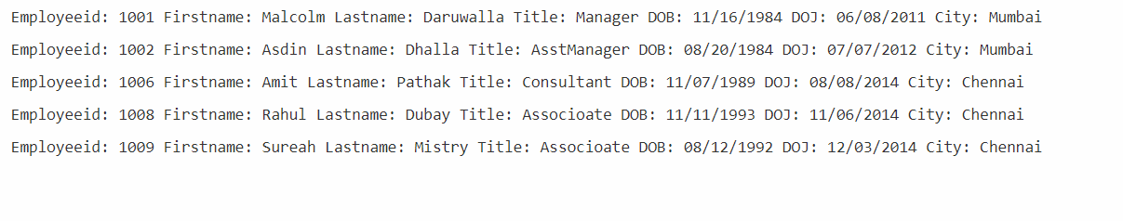

f. Display a list of all the employee whose date of birth is after 1/1/1990.

using System;

using System.Linq;

using System.Collections.Generic;

class Employee {

public int EmployeeID{get;set;}

public string FirstName{get;set;}

public string LastName{get;set;}

public string Title{get;set;}

public DateOnly DOB{get;set;}

public DateOnly DOJ{get;set;}

public string City{get;set;}

}

class Emp{

static void Main() {

List<Employee> ListEmployee=new List<Employee>();

ListEmployee.Add(new Employee(){EmployeeID=1001,FirstName="Malcolm",LastName="Daruwalla",Title="Manager",DOB= new DateOnly(1984,11,16),DOJ=new DateOnly(2011,6,8),City="Mumbai"});

ListEmployee.Add(new Employee(){EmployeeID=1002,FirstName="Asdin",LastName="Dhalla",Title="AsstManager",DOB=new DateOnly(1984,08,20),DOJ=new DateOnly(2012,07,7),City="Mumbai"});

ListEmployee.Add(new Employee(){EmployeeID=1003,FirstName="Madhavi",LastName="Oza",Title="Consultant",DOB=new DateOnly(1987,11,14),DOJ=new DateOnly( 2015,4,12),City="Pune"});

ListEmployee.Add(new Employee(){EmployeeID=1004,FirstName="Saba",LastName="Shaikh",Title="SE",DOB=new DateOnly(1990,6,3),DOJ=new DateOnly(2016,2,2),City="Pune"});

ListEmployee.Add(new Employee(){EmployeeID=1005,FirstName="Nazia",LastName="Shaikh",Title="SE",DOB=new DateOnly(1991,3,8),DOJ=new DateOnly(2016,6,2),City="Mumbai"});

ListEmployee.Add(new Employee(){EmployeeID=1006,FirstName="Amit",LastName="Pathak",Title="Consultant",DOB=new DateOnly(1989,11,7), DOJ=new DateOnly(2014,8,8),City="Chennai"});

ListEmployee.Add(new Employee(){EmployeeID=1007,FirstName="Vijay",LastName="Natrajan",Title="Consultant",DOB=new DateOnly(1989,12,2),DOJ=new DateOnly(2015,6,1),City="Mumbai"});

ListEmployee.Add(new Employee(){EmployeeID=1008,FirstName="Rahul",LastName="Dubay",Title="Associoate",DOB=new DateOnly(1993,11,11),DOJ=new DateOnly(2014,11,6),City="Chennai"});

ListEmployee.Add(new Employee(){EmployeeID=1009,FirstName="Sureah",LastName="Mistry",Title="Associoate",DOB=new DateOnly(1992,8,12),DOJ=new DateOnly(2014,12,3),City="Chennai"});

ListEmployee.Add(new Employee(){EmployeeID=1010,FirstName="Sumit",LastName="Shah",Title="Manager",DOB=new DateOnly(1991,4,12),DOJ=new DateOnly(2016,1,2),City="Pune"});

var disp=ListEmployee.Where(p=>p.DOB.Year>1990);

foreach(var EM in disp)

{

Console.WriteLine("Employeeid: {0} Firstname: {1} Lastname: {2} Title: {3} DOB: {4} DOJ: {5} City: {6}\n",EM.EmployeeID,EM.FirstName,EM.LastName,EM.Title,EM.DOB,EM.DOJ,EM.City);

}

}

}

OUTPUT:

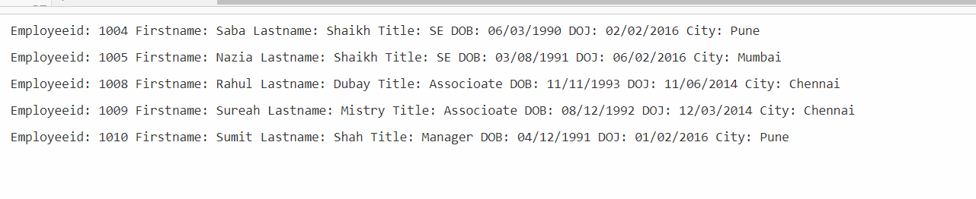

g .Display a list of all the employee whose designation is consultant and associate.

using System;

using System.Linq;

using System.Collections.Generic;

class Employee {

public int EmployeeID{get;set;}

public string FirstName{get;set;}

public string LastName{get;set;}

public string Title{get;set;}

public DateOnly DOB{get;set;}

public DateOnly DOJ{get;set;}

public string City{get;set;}

}

class Emp{

static void Main() {

List<Employee> ListEmployee=new List<Employee>();

ListEmployee.Add(new Employee(){EmployeeID=1001,FirstName="Malcolm",LastName="Daruwalla",Title="Manager",DOB= new DateOnly(1984,11,16),DOJ=new DateOnly(2011,6,8),City="Mumbai"});

ListEmployee.Add(new Employee(){EmployeeID=1002,FirstName="Asdin",LastName="Dhalla",Title="AsstManager",DOB=new DateOnly(1984,08,20),DOJ=new DateOnly(2012,07,7),City="Mumbai"});

ListEmployee.Add(new Employee(){EmployeeID=1003,FirstName="Madhavi",LastName="Oza",Title="Consultant",DOB=new DateOnly(1987,11,14),DOJ=new DateOnly( 2015,4,12),City="Pune"});

ListEmployee.Add(new Employee(){EmployeeID=1004,FirstName="Saba",LastName="Shaikh",Title="SE",DOB=new DateOnly(1990,6,3),DOJ=new DateOnly(2016,2,2),City="Pune"});

ListEmployee.Add(new Employee(){EmployeeID=1005,FirstName="Nazia",LastName="Shaikh",Title="SE",DOB=new DateOnly(1991,3,8),DOJ=new DateOnly(2016,6,2),City="Mumbai"});

ListEmployee.Add(new Employee(){EmployeeID=1006,FirstName="Amit",LastName="Pathak",Title="Consultant",DOB=new DateOnly(1989,11,7), DOJ=new DateOnly(2014,8,8),City="Chennai"});

ListEmployee.Add(new Employee(){EmployeeID=1007,FirstName="Vijay",LastName="Natrajan",Title="Consultant",DOB=new DateOnly(1989,12,2),DOJ=new DateOnly(2015,6,1),City="Mumbai"});

ListEmployee.Add(new Employee(){EmployeeID=1008,FirstName="Rahul",LastName="Dubay",Title="Associoate",DOB=new DateOnly(1993,11,11),DOJ=new DateOnly(2014,11,6),City="Chennai"});

ListEmployee.Add(new Employee(){EmployeeID=1009,FirstName="Sureah",LastName="Mistry",Title="Associoate",DOB=new DateOnly(1992,8,12),DOJ=new DateOnly(2014,12,3),City="Chennai"});

ListEmployee.Add(new Employee(){EmployeeID=1010,FirstName="Sumit",LastName="Shah",Title="Manager",DOB=new DateOnly(1991,4,12),DOJ=new DateOnly(2016,1,2),City="Pune"});

var disp = from i in ListEmployee where(i.Title=="Consultant"||i.Title=="Associoate")select i;

foreach(var EM in disp)

{

Console.WriteLine("{0} {1} {2} {3} {4} {5} {6}\n",EM.EmployeeID,EM.FirstName,EM.LastName,EM.Title,EM.DOB,EM.DOJ,EM.City);

}

}

}

Output:



h. Display Total number of employees.

using System;

using System.Linq;

using System.Collections.Generic;

class Employee {

public int EmployeeID{get;set;}

public string FirstName{get;set;}

public string LastName{get;set;}

public string Title{get;set;}

public DateOnly DOB{get;set;}

public DateOnly DOJ{get;set;}

public string City{get;set;}

}

class Emp{

static void Main() {

List<Employee> ListEmployee=new List<Employee>();

ListEmployee.Add(new Employee(){EmployeeID=1001,FirstName="Malcolm",LastName="Daruwalla",Title="Manager",DOB= new DateOnly(1984,11,16),DOJ=new DateOnly(2011,6,8),City="Mumbai"});

ListEmployee.Add(new Employee(){EmployeeID=1002,FirstName="Asdin",LastName="Dhalla",Title="AsstManager",DOB=new DateOnly(1984,08,20),DOJ=new DateOnly(2012,07,7),City="Mumbai"});

ListEmployee.Add(new Employee(){EmployeeID=1003,FirstName="Madhavi",LastName="Oza",Title="Consultant",DOB=new DateOnly(1987,11,14),DOJ=new DateOnly( 2015,4,12),City="Pune"});

ListEmployee.Add(new Employee(){EmployeeID=1004,FirstName="Saba",LastName="Shaikh",Title="SE",DOB=new DateOnly(1990,6,3),DOJ=new DateOnly(2016,2,2),City="Pune"});

ListEmployee.Add(new Employee(){EmployeeID=1005,FirstName="Nazia",LastName="Shaikh",Title="SE",DOB=new DateOnly(1991,3,8),DOJ=new DateOnly(2016,6,2),City="Mumbai"});

ListEmployee.Add(new Employee(){EmployeeID=1006,FirstName="Amit",LastName="Pathak",Title="Consultant",DOB=new DateOnly(1989,11,7), DOJ=new DateOnly(2014,8,8),City="Chennai"});

ListEmployee.Add(new Employee(){EmployeeID=1007,FirstName="Vijay",LastName="Natrajan",Title="Consultant",DOB=new DateOnly(1989,12,2),DOJ=new DateOnly(2015,6,1),City="Mumbai"});

ListEmployee.Add(new Employee(){EmployeeID=1008,FirstName="Rahul",LastName="Dubay",Title="Associoate",DOB=new DateOnly(1993,11,11),DOJ=new DateOnly(2014,11,6),City="Chennai"});

ListEmployee.Add(new Employee(){EmployeeID=1009,FirstName="Sureah",LastName="Mistry",Title="Associoate",DOB=new DateOnly(1992,8,12),DOJ=new DateOnly(2014,12,3),City="Chennai"});

ListEmployee.Add(new Employee(){EmployeeID=1010,FirstName="Sumit",LastName="Shah",Title="Manager",DOB=new DateOnly(1991,4,12),DOJ=new DateOnly(2016,1,2),City="Pune"});

var disp =(from i in ListEmployee select i).Count();

Console.WriteLine("Total number of employee:"+disp);

}

}

Output:

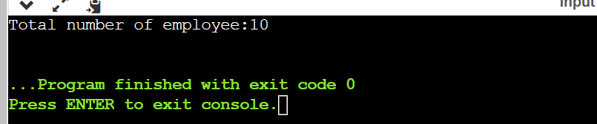

i.Display total number of employee belonging to Chennai.

using System;

using System.Linq;

using System.Collections.Generic;

class Employee {

public int EmployeeID{get;set;}

public string FirstName{get;set;}

public string LastName{get;set;}

public string Title{get;set;}

public DateOnly DOB{get;set;}

public DateOnly DOJ{get;set;}

public string City{get;set;}

}

class Emp{

static void Main() {

List<Employee> ListEmployee=new List<Employee>();

ListEmployee.Add(new Employee(){EmployeeID=1001,FirstName="Malcolm",LastName="Daruwalla",Title="Manager",DOB= new DateOnly(1984,11,16),DOJ=new DateOnly(2011,6,8),City="Mumbai"});

ListEmployee.Add(new Employee(){EmployeeID=1002,FirstName="Asdin",LastName="Dhalla",Title="AsstManager",DOB=new DateOnly(1984,08,20),DOJ=new DateOnly(2012,07,7),City="Mumbai"});

ListEmployee.Add(new Employee(){EmployeeID=1003,FirstName="Madhavi",LastName="Oza",Title="Consultant",DOB=new DateOnly(1987,11,14),DOJ=new DateOnly( 2015,4,12),City="Pune"});

ListEmployee.Add(new Employee(){EmployeeID=1004,FirstName="Saba",LastName="Shaikh",Title="SE",DOB=new DateOnly(1990,6,3),DOJ=new DateOnly(2016,2,2),City="Pune"});

ListEmployee.Add(new Employee(){EmployeeID=1005,FirstName="Nazia",LastName="Shaikh",Title="SE",DOB=new DateOnly(1991,3,8),DOJ=new DateOnly(2016,6,2),City="Mumbai"});

ListEmployee.Add(new Employee(){EmployeeID=1006,FirstName="Amit",LastName="Pathak",Title="Consultant",DOB=new DateOnly(1989,11,7), DOJ=new DateOnly(2014,8,8),City="Chennai"});

ListEmployee.Add(new Employee(){EmployeeID=1007,FirstName="Vijay",LastName="Natrajan",Title="Consultant",DOB=new DateOnly(1989,12,2),DOJ=new DateOnly(2015,6,1),City="Mumbai"});

ListEmployee.Add(new Employee(){EmployeeID=1008,FirstName="Rahul",LastName="Dubay",Title="Associoate",DOB=new DateOnly(1993,11,11),DOJ=new DateOnly(2014,11,6),City="Chennai"});

ListEmployee.Add(new Employee(){EmployeeID=1009,FirstName="Sureah",LastName="Mistry",Title="Associoate",DOB=new DateOnly(1992,8,12),DOJ=new DateOnly(2014,12,3),City="Chennai"});

ListEmployee.Add(new Employee(){EmployeeID=1010,FirstName="Sumit",LastName="Shah",Title="Manager",DOB=new DateOnly(1991,4,12),DOJ=new DateOnly(2016,1,2),City="Pune"});

var dis =(from i in ListEmployee where i.City=="Chennai" select i).Count();

Console.WriteLine("Total number of employee belonging to Chennai:"+dis);

}

}

Output:

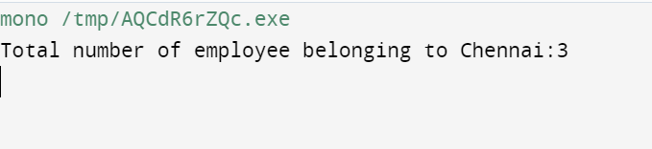

j. Display highest employee id from the list.

using System;

using System.Linq;

using System.Collections.Generic;

class Employee {

public int EmployeeID{get;set;}

public string FirstName{get;set;}

public string LastName{get;set;}

public string Title{get;set;}

public DateOnly DOB{get;set;}

public DateOnly DOJ{get;set;}

public string City{get;set;}

}

class Emp{

static void Main() {

List<Employee> ListEmployee=new List<Employee>();

ListEmployee.Add(new Employee(){EmployeeID=1001,FirstName="Malcolm",LastName="Daruwalla",Title="Manager",DOB= new DateOnly(1984,11,16),DOJ=new DateOnly(2011,6,8),City="Mumbai"});

ListEmployee.Add(new Employee(){EmployeeID=1002,FirstName="Asdin",LastName="Dhalla",Title="AsstManager",DOB=new DateOnly(1984,08,20),DOJ=new DateOnly(2012,07,7),City="Mumbai"});

ListEmployee.Add(new Employee(){EmployeeID=1003,FirstName="Madhavi",LastName="Oza",Title="Consultant",DOB=new DateOnly(1987,11,14),DOJ=new DateOnly( 2015,4,12),City="Pune"});

ListEmployee.Add(new Employee(){EmployeeID=1004,FirstName="Saba",LastName="Shaikh",Title="SE",DOB=new DateOnly(1990,6,3),DOJ=new DateOnly(2016,2,2),City="Pune"});

ListEmployee.Add(new Employee(){EmployeeID=1005,FirstName="Nazia",LastName="Shaikh",Title="SE",DOB=new DateOnly(1991,3,8),DOJ=new DateOnly(2016,6,2),City="Mumbai"});

ListEmployee.Add(new Employee(){EmployeeID=1006,FirstName="Amit",LastName="Pathak",Title="Consultant",DOB=new DateOnly(1989,11,7), DOJ=new DateOnly(2014,8,8),City="Chennai"});

ListEmployee.Add(new Employee(){EmployeeID=1007,FirstName="Vijay",LastName="Natrajan",Title="Consultant",DOB=new DateOnly(1989,12,2),DOJ=new DateOnly(2015,6,1),City="Mumbai"});

ListEmployee.Add(new Employee(){EmployeeID=1008,FirstName="Rahul",LastName="Dubay",Title="Associoate",DOB=new DateOnly(1993,11,11),DOJ=new DateOnly(2014,11,6),City="Chennai"});

ListEmployee.Add(new Employee(){EmployeeID=1009,FirstName="Sureah",LastName="Mistry",Title="Associoate",DOB=new DateOnly(1992,8,12),DOJ=new DateOnly(2014,12,3),City="Chennai"});

ListEmployee.Add(new Employee(){EmployeeID=1010,FirstName="Sumit",LastName="Shah",Title="Manager",DOB=new DateOnly(1991,4,12),DOJ=new DateOnly(2016,1,2),City="Pune"});

var dis =ListEmployee.Max(x=>x.EmployeeID);

Console.WriteLine("Highest EmployeeID:"+dis);

}

}



k. Display a list of all employee who have joined after 1/1/2015.

using System;

using System.Linq;

using System.Collections.Generic;

class Employee {

public int EmployeeID{get;set;}

public string FirstName{get;set;}

public string LastName{get;set;}

public string Title{get;set;}

public DateOnly DOB{get;set;}

public DateOnly DOJ{get;set;}

public string City{get;set;}

}

class Emp{

static void Main() {

List<Employee> ListEmployee=new List<Employee>();

ListEmployee.Add(new Employee(){EmployeeID=1001,FirstName="Malcolm",LastName="Daruwalla",Title="Manager",DOB= new DateOnly(1984,11,16),DOJ=new DateOnly(2011,6,8),City="Mumbai"});

ListEmployee.Add(new Employee(){EmployeeID=1002,FirstName="Asdin",LastName="Dhalla",Title="AsstManager",DOB=new DateOnly(1984,08,20),DOJ=new DateOnly(2012,07,7),City="Mumbai"});

ListEmployee.Add(new Employee(){EmployeeID=1003,FirstName="Madhavi",LastName="Oza",Title="Consultant",DOB=new DateOnly(1987,11,14),DOJ=new DateOnly( 2015,4,12),City="Pune"});

ListEmployee.Add(new Employee(){EmployeeID=1004,FirstName="Saba",LastName="Shaikh",Title="SE",DOB=new DateOnly(1990,6,3),DOJ=new DateOnly(2016,2,2),City="Pune"});

ListEmployee.Add(new Employee(){EmployeeID=1005,FirstName="Nazia",LastName="Shaikh",Title="SE",DOB=new DateOnly(1991,3,8),DOJ=new DateOnly(2016,6,2),City="Mumbai"});

ListEmployee.Add(new Employee(){EmployeeID=1006,FirstName="Amit",LastName="Pathak",Title="Consultant",DOB=new DateOnly(1989,11,7), DOJ=new DateOnly(2014,8,8),City="Chennai"});

ListEmployee.Add(new Employee(){EmployeeID=1007,FirstName="Vijay",LastName="Natrajan",Title="Consultant",DOB=new DateOnly(1989,12,2),DOJ=new DateOnly(2015,6,1),City="Mumbai"});

ListEmployee.Add(new Employee(){EmployeeID=1008,FirstName="Rahul",LastName="Dubay",Title="Associoate",DOB=new DateOnly(1993,11,11),DOJ=new DateOnly(2014,11,6),City="Chennai"});

ListEmployee.Add(new Employee(){EmployeeID=1009,FirstName="Sureah",LastName="Mistry",Title="Associoate",DOB=new DateOnly(1992,8,12),DOJ=new DateOnly(2014,12,3),City="Chennai"});

ListEmployee.Add(new Employee(){EmployeeID=1010,FirstName="Sumit",LastName="Shah",Title="Manager",DOB=new DateOnly(1991,4,12),DOJ=new DateOnly(2016,1,2),City="Pune"});

var disp=ListEmployee.Where(p=>p.DOJ.Year>=2015);

foreach(var EM in disp)

{

Console.WriteLine("Employeeid: {0} Firstname: {1} Lastname: {2} Title: {3} DOB: {4} DOJ: {5} City: {6}\n",EM.EmployeeID,EM.FirstName,EM.LastName,EM.Title,EM.DOB,EM.DOJ,EM.City);

}

}

}

OUTPUT:

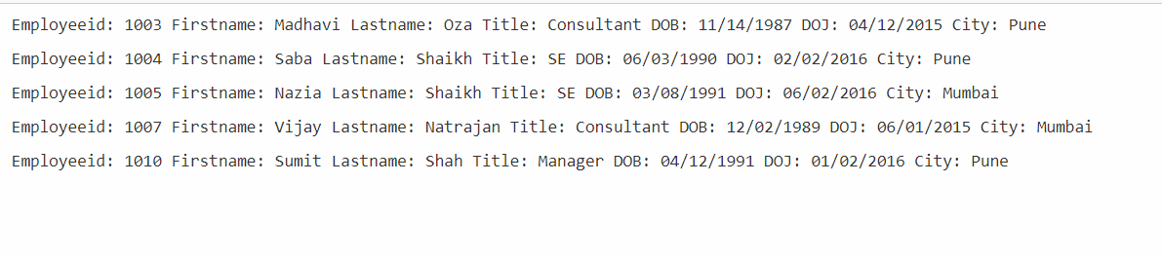

l. Display total number of the employee whose designation is not “Associate”.

using System;

using System.Linq;

using System.Collections.Generic;

class Employee {

public int EmployeeID{get;set;}

public string FirstName{get;set;}

public string LastName{get;set;}

public string Title{get;set;}

public DateOnly DOB{get;set;}

public DateOnly DOJ{get;set;}

public string City{get;set;}

}

class Emp{

static void Main() {

List<Employee> ListEmployee=new List<Employee>();

ListEmployee.Add(new Employee(){EmployeeID=1001,FirstName="Malcolm",LastName="Daruwalla",Title="Manager",DOB= new DateOnly(1984,11,16),DOJ=new DateOnly(2011,6,8),City="Mumbai"});

ListEmployee.Add(new Employee(){EmployeeID=1002,FirstName="Asdin",LastName="Dhalla",Title="AsstManager",DOB=new DateOnly(1984,08,20),DOJ=new DateOnly(2012,07,7),City="Mumbai"});

ListEmployee.Add(new Employee(){EmployeeID=1003,FirstName="Madhavi",LastName="Oza",Title="Consultant",DOB=new DateOnly(1987,11,14),DOJ=new DateOnly( 2015,4,12),City="Pune"});

ListEmployee.Add(new Employee(){EmployeeID=1004,FirstName="Saba",LastName="Shaikh",Title="SE",DOB=new DateOnly(1990,6,3),DOJ=new DateOnly(2016,2,2),City="Pune"});

ListEmployee.Add(new Employee(){EmployeeID=1005,FirstName="Nazia",LastName="Shaikh",Title="SE",DOB=new DateOnly(1991,3,8),DOJ=new DateOnly(2016,6,2),City="Mumbai"});

ListEmployee.Add(new Employee(){EmployeeID=1006,FirstName="Amit",LastName="Pathak",Title="Consultant",DOB=new DateOnly(1989,11,7), DOJ=new DateOnly(2014,8,8),City="Chennai"});

ListEmployee.Add(new Employee(){EmployeeID=1007,FirstName="Vijay",LastName="Natrajan",Title="Consultant",DOB=new DateOnly(1989,12,2),DOJ=new DateOnly(2015,6,1),City="Mumbai"});

ListEmployee.Add(new Employee(){EmployeeID=1008,FirstName="Rahul",LastName="Dubay",Title="Associoate",DOB=new DateOnly(1993,11,11),DOJ=new DateOnly(2014,11,6),City="Chennai"});

ListEmployee.Add(new Employee(){EmployeeID=1009,FirstName="Sureah",LastName="Mistry",Title="Associoate",DOB=new DateOnly(1992,8,12),DOJ=new DateOnly(2014,12,3),City="Chennai"});

ListEmployee.Add(new Employee(){EmployeeID=1010,FirstName="Sumit",LastName="Shah",Title="Manager",DOB=new DateOnly(1991,4,12),DOJ=new DateOnly(2016,1,2),City="Pune"});

var dis =(from i in ListEmployee where i.Title!="Associoate"select i).Count();

Console.WriteLine("Total Number of employee whose Designation is not Associoate:"+dis);

}

}

Output:

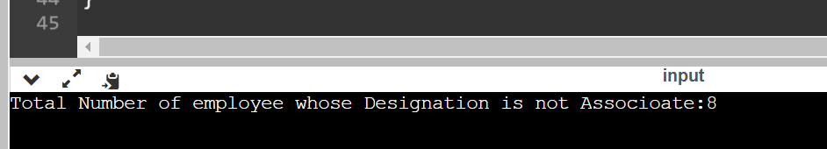

m. Display total number of employee based on city.

using System;

using System.Linq;

using System.Collections.Generic;

class Employee {

public int EmployeeID{get;set;}

public string FirstName{get;set;}

public string LastName{get;set;}

public string Title{get;set;}

public DateOnly DOB{get;set;}

public DateOnly DOJ{get;set;}

public string City{get;set;}

}

class Emp{

static void Main() {

List<Employee> ListEmployee=new List<Employee>();

ListEmployee.Add(new Employee(){EmployeeID=1001,FirstName="Malcolm",LastName="Daruwalla",Title="Manager",DOB= new DateOnly(1984,11,16),DOJ=new DateOnly(2011,6,8),City="Mumbai"});

ListEmployee.Add(new Employee(){EmployeeID=1002,FirstName="Asdin",LastName="Dhalla",Title="AsstManager",DOB=new DateOnly(1984,08,20),DOJ=new DateOnly(2012,07,7),City="Mumbai"});

ListEmployee.Add(new Employee(){EmployeeID=1003,FirstName="Madhavi",LastName="Oza",Title="Consultant",DOB=new DateOnly(1987,11,14),DOJ=new DateOnly( 2015,4,12),City="Pune"});

ListEmployee.Add(new Employee(){EmployeeID=1004,FirstName="Saba",LastName="Shaikh",Title="SE",DOB=new DateOnly(1990,6,3),DOJ=new DateOnly(2016,2,2),City="Pune"});

ListEmployee.Add(new Employee(){EmployeeID=1005,FirstName="Nazia",LastName="Shaikh",Title="SE",DOB=new DateOnly(1991,3,8),DOJ=new DateOnly(2016,6,2),City="Mumbai"});

ListEmployee.Add(new Employee(){EmployeeID=1006,FirstName="Amit",LastName="Pathak",Title="Consultant",DOB=new DateOnly(1989,11,7), DOJ=new DateOnly(2014,8,8),City="Chennai"});

ListEmployee.Add(new Employee(){EmployeeID=1007,FirstName="Vijay",LastName="Natrajan",Title="Consultant",DOB=new DateOnly(1989,12,2),DOJ=new DateOnly(2015,6,1),City="Mumbai"});

ListEmployee.Add(new Employee(){EmployeeID=1008,FirstName="Rahul",LastName="Dubay",Title="Associoate",DOB=new DateOnly(1993,11,11),DOJ=new DateOnly(2014,11,6),City="Chennai"});

ListEmployee.Add(new Employee(){EmployeeID=1009,FirstName="Sureah",LastName="Mistry",Title="Associoate",DOB=new DateOnly(1992,8,12),DOJ=new DateOnly(2014,12,3),City="Chennai"});

ListEmployee.Add(new Employee(){EmployeeID=1010,FirstName="Sumit",LastName="Shah",Title="Manager",DOB=new DateOnly(1991,4,12),DOJ=new DateOnly(2016,1,2),City="Pune"});

var dis= from c in ListEmployee group c by c.City;

foreach(var EM in dis)

{

Console.WriteLine("{0} {1} ",EM.Key,EM.Count());

}

}

}

Output:

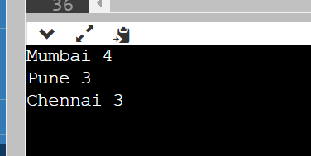

n. Display total number of employee based on city and title.  
using System;

using System.Linq;

using System.Collections.Generic;

class Employee {

public int EmployeeID{get;set;}

public string FirstName{get;set;}

public string LastName{get;set;}

public string Title{get;set;}

public DateOnly DOB{get;set;}

public DateOnly DOJ{get;set;}

public string City{get;set;}

}

class Emp{

static void Main() {

List<Employee> ListEmployee=new List<Employee>();

ListEmployee.Add(new Employee(){EmployeeID=1001,FirstName="Malcolm",LastName="Daruwalla",Title="Manager",DOB= new DateOnly(1984,11,16),DOJ=new DateOnly(2011,6,8),City="Mumbai"});

ListEmployee.Add(new Employee(){EmployeeID=1002,FirstName="Asdin",LastName="Dhalla",Title="AsstManager",DOB=new DateOnly(1984,08,20),DOJ=new DateOnly(2012,07,7),City="Mumbai"});

ListEmployee.Add(new Employee(){EmployeeID=1003,FirstName="Madhavi",LastName="Oza",Title="Consultant",DOB=new DateOnly(1987,11,14),DOJ=new DateOnly( 2015,4,12),City="Pune"});

ListEmployee.Add(new Employee(){EmployeeID=1004,FirstName="Saba",LastName="Shaikh",Title="SE",DOB=new DateOnly(1990,6,3),DOJ=new DateOnly(2016,2,2),City="Pune"});

ListEmployee.Add(new Employee(){EmployeeID=1005,FirstName="Nazia",LastName="Shaikh",Title="SE",DOB=new DateOnly(1991,3,8),DOJ=new DateOnly(2016,6,2),City="Mumbai"});

ListEmployee.Add(new Employee(){EmployeeID=1006,FirstName="Amit",LastName="Pathak",Title="Consultant",DOB=new DateOnly(1989,11,7), DOJ=new DateOnly(2014,8,8),City="Chennai"});

ListEmployee.Add(new Employee(){EmployeeID=1007,FirstName="Vijay",LastName="Natrajan",Title="Consultant",DOB=new DateOnly(1989,12,2),DOJ=new DateOnly(2015,6,1),City="Mumbai"});

ListEmployee.Add(new Employee(){EmployeeID=1008,FirstName="Rahul",LastName="Dubay",Title="Associoate",DOB=new DateOnly(1993,11,11),DOJ=new DateOnly(2014,11,6),City="Chennai"});

ListEmployee.Add(new Employee(){EmployeeID=1009,FirstName="Sureah",LastName="Mistry",Title="Associoate",DOB=new DateOnly(1992,8,12),DOJ=new DateOnly(2014,12,3),City="Chennai"});

ListEmployee.Add(new Employee(){EmployeeID=1010,FirstName="Sumit",LastName="Shah",Title="Manager",DOB=new DateOnly(1991,4,12),DOJ=new DateOnly(2016,1,2),City="Pune"});

var disp= from c in ListEmployee group c by new {c.Title, c.City } into NewGroup orderby NewGroup.Key.City select new {CITY= NewGroup.Key.City,Title= NewGroup.Key.Title ,Count = NewGroup.Count()};

foreach(var EM in disp)

{

Console.WriteLine("{0} {1} {2} ",EM.CITY,EM.Title,EM.Count);

}

}

}

Output:

